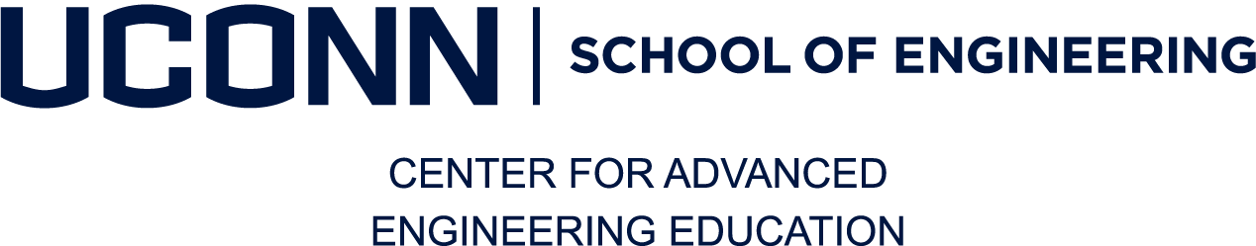
UConn Alumni Discount Request
The UConn School of Engineering Center for Advanced Engineering Education prides itself on its competitive pricing and the value of the education provided to our students. We are proud to offer School of Engineering alumni an exclusive discount of 10% off all program fees. The discount cannot be combined with any other discount or company sponsored tuition reimbursement program.

Please complete the form below to request the discount.

Biographical Information | U.S. Citizen: Yes ☐ No ☐
Student Admin #: | Birth Date:
Gender: Male ☐ Female ☐ | Current Employer:
Last Name: | First Name: | Middle Initial:
Home Address: | Daytime Phone:
 | Cell Phone:
Email:

Yr Degree Awarded | Field of Study

Student Signature
By signing this form, the student acknowledges that they are a self pay student and are not receiving reimbursement from an employer and/or are not part of a veteran’s waiver program.

Signature of the Student______________________________________ DATE_________________

EMAIL COMPLETED FORM TO engrcaee@uconn.edu

For Office Use Only:

Degree Confirmed: ___________________ Grant Advice Processed: ___________________

Note:

